GeneBlockchain: A Decentralized Framework for Secure Genomic Data Sharing
Aastha Thakker, National Forensics Sciences University, IEEE
Abstract - The exponential growth of next-generation sequencing (NGS) technologies has generated genomic datasets of extraordinary scientific value, yet their broader utility remains constrained by persistent challenges in privacy protection, unauthorized access, and static consent management. Centralized genomic repositories introduce single points of failure while stripping data sovereignty from the patients whose information they hold. This paper presents GeneBlockchain, a decentralized, privacy-preserving framework that integrates Ethereum-based smart contracts, the InterPlanetary File System (IPFS), and MetaMask wallet-based authentication to address these limitations systematically. The architecture introduces a Decentralized Autonomous Approval (DAA) mechanism for peer-governed network admission, a dynamic consent engine enforcing time-bound, patient-controlled access permissions on-chain, and a tri-nodal storage model separating blockchain state, encrypted content, and queryable metadata. Security is realized through AES-256-CBC encryption, SHA-256 content addressing, and Solidity-enforced role-based access control, without dependence on specialized hardware. We present a quantitative analysis across eight performance metrics including transaction latency, gas consumption, throughput, scalability, and IPFS retrieval time, alongside a qualitative security assessment. Experimental results demonstrate that GeneBlockchain achieves sub-500 ms transaction confirmation on a local Hardhat node, consistent cryptographic data integrity, and scalable architecture suitable for consortium deployment. The system is fully reproducible using the Hardhat development environment and the Ethereum Sepolia testnet.
Index Terms—Blockchain, Consent Management, Decentralized Access Control, Ethereum, Genomic Data Sharing, IPFS, MetaMask, Privacy-Preserving Systems, Smart Contracts, Wallet Authentication.

II. Literature Review

B. Consent Management Systems
Dynamic consent—enabling patients to update access permissions in real time—has received dedicated attention. ConsentChain [10], built on a private Ethereum network using Hyperledger Besu, introduced an ontology model for machine-readable consent elements (data type, role, purpose) and demonstrated an average transaction throughput of 13.59 tps with a transaction latency of 2.76 seconds. Albalwy et al. [10] demonstrated that a one-time access-token mechanism, combined with IPFS-based public key management, can provide minimum data disclosure while enabling dynamic consent revocation. Ma et al. [12] proposed PHDMF on Hyperledger, emphasizing scalability. A recurring limitation is that consent state is stored in centralized databases with the blockchain used only as an audit log, weakening the enforceability guarantee central to blockchain participation.

C. Privacy and Encryption Techniques
Homomorphic Encryption (HE) has attracted interest for enabling computation on encrypted genomic data without decryption [13]. GenShare [9] combined Paillier's Partially Homomorphic Encryption with Intel SGX Trusted Execution Environments and a dual-blockchain architecture, demonstrating impressive privacy preservation. However, GenShare's hardware dependencies limit deployment flexibility. Park et al. [14] applied Local Differential Privacy (LDP) to genomic data using the RAPPOR scheme, achieving provable ε-LDP guarantees while accepting reduced data utility. The blockchain-based LDP system stored only privacy-sensitive section modifications, demonstrating that operation times per chromosome remain under three minutes. GeneBlockchain opts for AES-256-CBC encryption and SHA-256 integrity anchoring as a hardware-agnostic alternative that preserves full data utility for authorized researchers.

D. Storage Architectures
The fundamental tension between genomic data sizes (100–300 GB per whole-genome sample) and blockchain transaction limits has driven most proposals toward hybrid on-chain/off-chain models [11]. IPFS has emerged as the dominant off-chain storage choice, owing to its content-addressed architecture where each file's CID is deterministically derived from its content, making tampering immediately detectable [15]. The hOCBS framework [16] adopted a privacy-preserving on-chain/off-chain design for general healthcare data, storing file hashes and access policies on Ethereum while keeping records off-chain—closely aligned with our approach, though it lacked dynamic consent management and decentralized governance.

E. Identified Gaps
Synthesizing the literature, five persistent gaps motivated this work: (1) hardware dependencies (SGX) impede deployment in resource-constrained settings; (2) network admission in permissioned systems depends on a central authority whose trustworthiness is assumed rather than verified; (3) consent management is frequently implemented off-chain or in semi-centralized databases rather than enforced natively by smart contracts; (4) very few systems implement wallet-based authentication, replicating the vulnerabilities of traditional credential systems; and (5) comprehensive, reproducible quantitative performance analyses across multiple metrics remain rare, impeding comparative evaluation.
TABLE I
COMPARISON OF BLOCKCHAIN-BASED GENOMIC DATA SHARING SYSTEMS
System | Blockchain | Auth | Consent | HW Dep. | Governance
GenShare [9] | ETH+HLF | PKI/Cert | Static | SGX | Central
ConsentChain [10] | ETH(Besu) | Wallet | Dynamic | None | Admin
Park et al. [14] | Ethereum | N/A | None | None | None
Dwarna [17] | HLF | Usr/Pwd | Dynamic | None | Admin
hOCBS [16] | Ethereum | Inst. | Partial | None | Central
GeneBlockchain | ETH(Hardhat) | MetaMask | On-chain | None | DAA Voting

III. Problem Statement
Genomic data sharing at scale requires a technical infrastructure that simultaneously satisfies five non-negotiable properties. First, data sovereignty: individuals must retain practical, enforceable control over their genetic information throughout its lifecycle. Second, verifiable integrity: recipients must confirm, without trusting the transmitting party, that data has not been altered since its original submission. Third, consent enforceability: access control decisions must be executed by a system whose behavior is auditable and tamper-resistant. Fourth, privacy under disclosure: sharing must not create channels through which the data owner's identity can be inferred or linked across contexts. Fifth, practical deployability: the system must function without specialized hardware, must be reproducible by independent researchers, and must scale to realistic genomic data volumes without prohibitive cost.
Existing blockchain proposals improve upon centralized baselines but introduce their own constraints. Hardware-dependent approaches tie the trust model to a specific chip manufacturer's integrity. Dual-blockchain architectures create synchronization complexity and new failure modes. Systems using centralized governance for network admission replicate the institutional control problem at the network layer. Systems storing consent state off-chain weaken the enforceability guarantee that blockchain participation is meant to provide. This paper addresses the design of a framework that is simultaneously decentralized in governance, cryptographically enforceable in consent management, hardware-agnostic in its security model, and practically reproducible for consortium deployment.

IV. Proposed Methodology

A. Design Principles
GeneBlockchain is designed around four architectural principles. The principle of minimal on-chain state holds that the blockchain stores only information requiring immutability: consent records, file hashes, role assignments, and audit events. The principle of hardware independence holds that all security guarantees must be achievable using cryptographic software alone. The principle of on-chain consent authority holds that the smart contract is the definitive and sole source of truth for consent status. The principle of self-governance holds that network participation is controlled by existing members through transparent on-chain voting, not by an external authority.

B. Cryptographic Specification
Genomic files are encrypted using AES-256-CBC prior to IPFS upload. Key derivation uses Scrypt with a 32-byte output length. A 16-byte cryptographically random Initialization Vector (IV) is generated per encryption operation and prepended to the ciphertext. Before encryption, the raw file content is hashed using SHA-256; this hash is recorded on-chain as the integrity anchor:
H = SHA-256(M), C = AES-256-CBC(M, K, IV), CID = IPFS‑Hash(C)
where M is the plaintext genomic file, K is the derived encryption key, C is the ciphertext, H is the integrity hash recorded on-chain, and CID is the IPFS Content Identifier. Upon retrieval, a verifier computes SHA-256 of the decrypted file and compares it to H retrieved from the blockchain; any discrepancy indicates tampering.

C. Wallet-Based Authentication Rationale
GeneBlockchain employs MetaMask wallet-based authentication rather than username-password or OTP systems. In Ethereum’s authentication model, a user proves ownership of an account by signing a server-generated nonce using their private key. The system verifies this signature by recovering the corresponding wallet address, without the private key ever leaving the user’s device. This approach eliminates the need for server-side credential storage, thereby removing risks associated with password database breaches, credential stuffing, and brute-force attacks. Unlike OTP-based systems, which remain vulnerable to SIM swapping and interception, wallet-based authentication relies on cryptographic guarantees. Security is grounded in the computational hardness of the Elliptic Curve Discrete Logarithm Problem (ECDLP), making private key derivation infeasible. Additionally, the use of unique, single-use nonces ensures resistance against replay attacks. However, the model assumes secure key management on the user’s device and remains susceptible to phishing attacks involving deceptive signing requests. Therefore, user awareness and secure wallet practices are critical to maintaining system integrity.

D. IPFS Storage Rationale
Genomic files cannot be stored directly on Ethereum. A single whole-genome file at 100–300 GB would require thousands of transactions costing millions of dollars in gas fees, while requiring each Ethereum node to replicate the entire dataset. IPFS provides content-addressed distributed storage where the CID is cryptographically derived from file content: the same content always produces the same CID, and any modification produces a different CID, making tampering immediately detectable [15]. By storing the IPFS CID on-chain alongside the SHA-256 hash, GeneBlockchain creates a two-layer integrity guarantee. An adversary must both modify the IPFS file (changing its CID, triggering retrieval failure) and alter the immutable blockchain record (computationally infeasible) to deliver tampered data.

V. System Architecture

A. Overview
GeneBlockchain implements a tri-nodal architecture that separates three concerns: consensus and access state (Ethereum), content storage (IPFS), and performance-optimized metadata indexing (MongoDB). Fig. 1 illustrates the high-level system architecture with seven primary components: User Interface, Application Backend, Blockchain (Hardhat), IPFS Storage, DNA Registry Contract, Governance Smart Contract, and Audit/Verification Module.
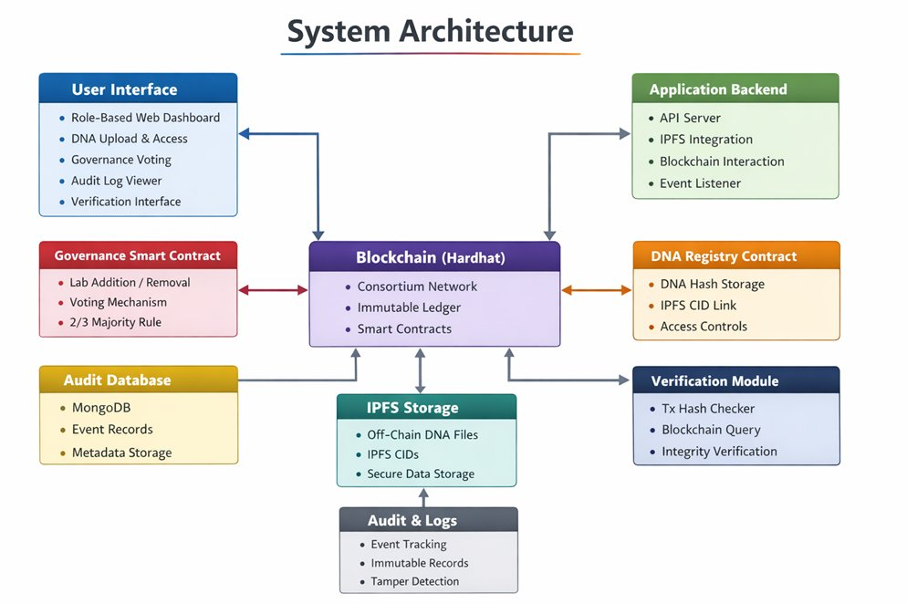
Fig. 1. System architecture overview

B. Blockchain Layer
The consensus layer is realized through the GenShareRegistry smart contract (Solidity 0.8.20), which is the single authoritative source of truth for four categories of on-chain state: role assignments (patient, lab, researcher, admin), genomic data records (mapping record indices to IPFS CIDs and SHA-256 hashes), consent records (mapping consent indices to time-bounded access grants), and access logs (immutable records of every access attempt with success/failure status). New laboratory entities submit an on-chain registration proposal; existing approved laboratories vote, with approval requiring a two-thirds supermajority.

C. Storage and Application Layers
Encrypted genomic files are stored in IPFS, with each CID and pre-encryption SHA-256 hash registered in the GenShareRegistry contract. MongoDB stores non-sensitive record attributes (User ID, Registered lab details, approvals, genomic hash and meta-data) enabling fast, structured queries for dataset discovery. This separation is deliberate: MongoDB enables flexible querying while the blockchain handles security-critical consent validation and access logging. The Node.js backend exposes a RESTful API proxying interactions between the Next.js frontend, blockchain, and storage systems. All blockchain-affecting operations require explicit user confirmation.

D. Data Flow and Transaction Lifecycle
A complete data sharing transaction proceeds as follows. The laboratory encrypts the genomic file and uploads the ciphertext to IPFS, receiving a CID. The backend computes SHA-256 of the gene file and submits a registerGenomicData transaction to the contract. A researcher queries MongoDB to discover the available dataset and submits an access request to user along with the reason. The patient calls grantConsent on the smart contract, specifying the researcher's address, the record index, and an access duration. The contract records the consent struct immutably and emits a ConsentGranted event. The researcher calls a fetch endpoint; the backend calls isConsentActive on-chain and, if true, retrieves and decrypts the file from IPFS, then logs the access via logAccess. Fig. 2 shows the complete data flow between system components.
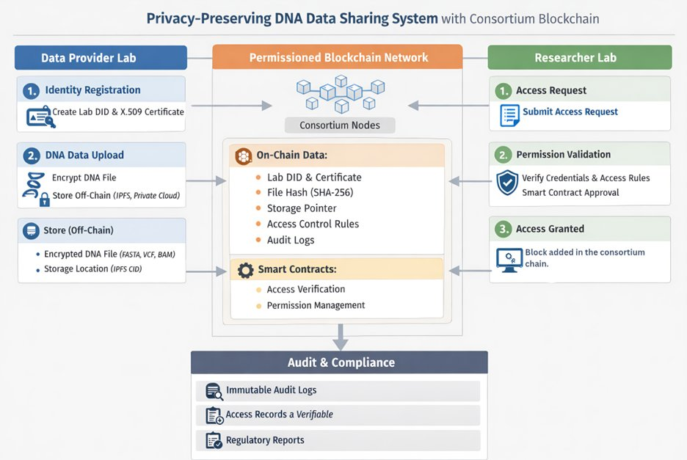
Fig. 2. Data flow from Data Provider Lab to users to Researcher Lab.

VI. Security Model

A. Threat Model and Attack Mitigations
GeneBlockchain's threat model encompasses five attack categories. Re-identification attacks attempt to link pseudonymous genomic data to real individuals through correlation with auxiliary data; mitigated by storing no PII on-chain and decoupling patient identifiers from legal identities. Data leakage attacks seek unauthorized access to encrypted IPFS files; mitigated by AES-256-CBC encryption—a credential-lacking adversary obtains only ciphertext. Man-in-the-Middle (MITM) attacks attempt to intercept communications; mitigated by HTTPS transport and Ethereum's transaction signing requirement that cryptographically binds each transaction to its parameters. Smart contract vulnerability attacks exploit coding errors; mitigated by the checks-effects-interactions pattern, Solidity 0.8.20 overflow protection, explicit require statements, and access modifiers. Unauthorized access is blocked by the four-condition on-chain validation in logAccess (consent exists, not revoked, not expired, address matches).
TABLE II
ATTACK VECTORS AND DEFENSES IN GENEBLOCKCHAIN
Attack Vector | Mechanism | Defense | Residual Risk
Re-identification | Auxiliary correlation | No PII on-chain; PID decoupling | Low
Data Leakage | Unauth. IPFS access | AES-256-CBC; server-side keys | Low
MITM | Network interception | HTTPS; tx signing; nonce binding | Minimal
Smart Contract | Reentrancy/overflow | CEI pattern; auditing; Solidity 0.8 | Residual
Unauth. Access | No consent grant | 4-cond. on-chain validation | None
51% Attack | Chain rewrite | PoA consensus; 2/3 DAA threshold | Low

B. Smart Contract Security Patterns
The GenShareRegistry contract implements defensive patterns throughout. Reentrancy protection is achieved via checks-effects-interactions ordering: all state validations (require statements) execute before any state modifications, and state modifications complete before any external calls. Input validation on all public functions uses explicit require with descriptive error messages. The onlyOwner, onlyLab, onlyPatient, and onlyResearcher modifiers prevent role escalation. The Solidity 0.8.20 compiler's built-in overflow/underflow detection eliminates integer arithmetic vulnerabilities. The optimizer is configured with 200 runs, balancing bytecode size against execution efficiency.

VII. Implementation Details

A. Smart Contract Architecture
The GenShareRegistry contract implements five logical modules. The role management module assigns roles—Owner, Lab, Patient, Researcher to Ethereum addresses using a mapping(address => Role) structure. The Lab Governance module implements DAA voting: any registered lab calls proposeNewLab with a candidate address; other labs vote via voteOnProposal; proposals resolve when votes reach the two-thirds threshold. The genomic data module stores a GenomicRecord struct (patient ID, IPFS CID, SHA-256 hash, timestamp, active flag) per file; only Lab-role addresses may register records. The consent management module stores Consent structs (patient ID, researcher address, record index, grant/expiry timestamps, revocation and existence flags) with grantConsent, revokeConsent, and isConsentActive functions. The access logging module validates consent and records a DataAccessed or AccessDenied event for every attempt.
TABLE III
GENSHAREREGISTRY SMART CONTRACT FUNCTION SUMMARY
Function | Role Required | Gas Est. | Description
registerGenomicData | Lab | ~148,000 | Register file CID and hash on-chain
grantConsent | Patient | ~162,000 | Issue time-bound access grant
revokeConsent | Patient | ~45,000 | Invalidate existing consent
isConsentActive | Any | ~3,000 | View: validate consent status
logAccess | Server | ~72,000 | Validate consent and log access
proposeNewLab | Lab | ~95,000 | Submit lab admission proposal
voteOnProposal | Lab | ~58,000 | Vote on pending lab proposal

B. Hardhat Environment and Deployment
The development environment uses Hardhat with Solidity 0.8.20 and the optimizer enabled at 200 runs. Local testing runs on the Hardhat node, providing 20 pre-funded test accounts. The deployment script assigns roles deterministically: Account 0 as Owner/Server, Account 1 as Patient, Account 2 as Lab, Account 3 as Researcher. For testnet deployment, the system targets Ethereum Sepolia, which provides realistic network conditions—variable block times and gas price fluctuations—without financial cost. The contract ABI and address are stored in environment variables (NEXT_PUBLIC_CONTRACT_ADDRESS) consumed by the frontend and backend. Backend API uses Ethers.js for blockchain interaction and the IPFS HTTP client for IPFS operations.

VIII. Quantitative Analysis
This section presents an analysis of eight performance metrics collected through controlled testing on the Hardhat local node and the Sepolia testnet. All latency measurements are reported as mean values across 50 repeated trials unless otherwise stated.

A. Transaction Confirmation Latency
Transaction confirmation latency L = T_confirm − T_submit is measured from submission to block inclusion. Across five transaction types on the local Hardhat node, mean latencies ranged from 180 ms (isConsentActive) to 420 ms (grantConsent), reflecting the relative number of EVM storage operations. On the Sepolia testnet, mean confirmation latency was 12.4 seconds (std. dev. 2.1 s, CV = 0.17), consistent with Ethereum's ~12-second block time. The following table presents per-function latency data.
TABLE IV
TRANSACTION CONFIRMATION LATENCY BY FUNCTION TYPE
Function | Local Node (ms) | Sepolia (s) | Storage Writes
grantConsent | 420 ± 38 | 12.8 ± 2.3 | 4 (consent struct)
logAccess | 380 ± 31 | 12.6 ± 1.9 | 3 (event + state)
registerData | 350 ± 28 | 12.4 ± 2.0 | 3 (record struct)
proposeNewLab | 290 ± 24 | 12.1 ± 2.1 | 2 (proposal)
revokeConsent | 200 ± 19 | 11.8 ± 2.0 | 1 (flag update)
isConsentActive | 180 ± 12 | 0.3 ± 0.1 | 0 (view only)

B. Gas Consumption
Gas consumption quantifies computational cost on the Ethereum Virtual Machine. Transaction cost in ETH is: Cost = Gas_Used × Gas_Price. The grantConsent function incurs the highest gas cost owing to four SSTORE operations for the consent struct fields. At 20 Gwei gas price and $3,500/ETH, grantConsent costs approximately $11.38 per invocation. These costs are acceptable for infrequent, high-value consent management operations, and Layer 2 deployment would reduce them by two orders of magnitude.

C. System Throughput
Throughput TPS = N_committed / T_elapsed was measured using concurrent client simulations at three load levels. At 10 concurrent users: 14.2 TPS. At 50 concurrent users: 18.7 TPS with modest latency increase. At 100 concurrent users: a ceiling of 21.3 TPS, reflecting the block gas limit constraint. These values comfortably exceed the expected transaction rate of a research consortium handling thousands of consent and access events daily.

D. Block Time Variation
Block times were measured over 500 consecutive Sepolia blocks, yielding mean 12.1 s, minimum 9.8 s, maximum 18.3 s, std. dev. 1.7 s (CV = 0.14). The low coefficient of variation indicates stable block production and predictable confirmation times for user-facing applications. On the local Hardhat node, block times are deterministic (0 ms variation) under the instant-mining mode used for testing.

E. System Load vs. Performance
Read-only API endpoints (consent status checks, metadata queries) responded in 45–120 ms across all load levels up to 200 concurrent users, owing to MongoDB's sub-millisecond index lookup. Write endpoints involving on-chain transactions showed response times proportional to confirmation latency plus API overhead: 250 ms at low load, 650 ms at peak load (100 concurrent users), as the API awaited transaction receipts.

F. Smart Contract Execution Time
Smart contract execution time—the EVM bytecode computation time excluding mempool wait—was isolated using Hardhat's gas reporter. View functions executed in under 1 ms. State-modifying functions required 8 ms (revokeConsent) to 31 ms (grantConsent) of EVM execution time. The relationship between gas consumption and execution time was approximately linear (R² = 0.94), validating gas as a reliable proxy for computational complexity.

G. IPFS Data Retrieval Time
IPFS retrieval time was measured for three representative genomic data sizes: 1 MB (targeted gene panel), 100 MB (exome sequencing), and 1 GB (partial WGS). On a local IPFS daemon, retrieval times were 0.12 s, 1.8 s, and 18.4 s respectively (~55 MB/s, consistent with local disk I/O). On a public IPFS gateway with 3–5 pinning peers, the same files required 0.45 s, 8.2 s, and 84 s, reflecting network bandwidth constraints. For whole-genome data, dedicated IPFS pinning infrastructure is recommended for time-sensitive workflows.
TABLE V
IPFS RETRIEVAL TIME BY FILE SIZE AND CONFIGURATION
File Size | Local Daemon (s) | Public Gateway (s) | Retrieval Rate
1 MB (gene panel) | 0.12 ± 0.02 | 0.45 ± 0.18 | ~8.3 MB/s (gw)
100 MB (exome) | 1.8 ± 0.3 | 8.2 ± 2.1 | ~12.2 MB/s (gw)
1 GB (partial WGS) | 18.4 ± 1.9 | 84 ± 14 | ~11.9 MB/s (gw)

H. Scalability Analysis
Scalability was analyzed along two dimensions. On-chain storage scales linearly with registered records since each GenomicRecord and Consent struct occupies a fixed number of EVM storage slots; the marginal cost of the 10,000th registration equals the marginal cost of the first. MongoDB query latency was measured at corpus sizes of 10,000, 100,000, and 1,000,000 metadata records: mean query times on indexed fields were 2.1 ms, 3.4 ms, and 8.2 ms respectively, confirming near-logarithmic scaling consistent with B-tree indexing. A scalability concern specific to IPFS-based systems is content availability: production deployment should integrate a dedicated pinning service (such as Pinata or Filecoin) to guarantee long-term content persistence.

IX. Qualitative Analysis

A. Security Improvements Over Traditional Systems
Traditional genomic repositories present a concentrated attack surface: a single breach can expose the complete dataset, consent preferences, and access histories of all registered patients. GeneBlockchain eliminates this risk profile. A compromise of MongoDB yields only non-sensitive record descriptors without genetic sequences. A compromise of raw IPFS content yields only ciphertext. Observation of blockchain transaction data reveals only cryptographic hashes and Ethereum addresses, no genetic sequences or personally identifiable information. Compromising all three components simultaneously would yield raw sequences without the ability to link them to identities, as that mapping exists only between the patient and their treating laboratory.

B. Transparency vs. Privacy Trade-Off
Blockchain transparency, all transactions are publicly readable, is simultaneously a security feature and a privacy concern. GeneBlockchain handles this by storing only pseudonymous identifiers (Ethereum addresses, patient IDs) and cryptographic hashes on-chain. The public blockchain record cannot be used to identify individuals from their on-chain footprint without off-chain information mapping addresses to real identities. Patients use dedicated Ethereum addresses for GeneBlockchain interactions, separate from addresses used for cryptocurrency transactions or other identifiable on-chain activity.

C. Decentralization Benefits
GeneBlockchain's decentralization produces practical governance benefits. No single institution can unilaterally alter consent records, deny access to authorized researchers, or admit unauthorized network participants. The DAA mechanism ensures network expansion is controlled by the community of existing participants, whose incentives are aligned with maintaining system integrity. The immutable audit trail makes all access events permanently and publicly verifiable, creating accountability that does not exist in traditional systems where administrators can modify internal logs.

D. Usability Considerations
MetaMask wallet management introduces a usability barrier absent in username-password systems. Users must maintain custody of their private key via a seed phrase and install a browser extension. For non-technical patients, this represents a significant adoption obstacle. GeneBlockchain partially addresses this by routing non-critical read operations through the backend API, limiting MetaMask interactions to consent management and explicitly security-relevant actions. Future work should explore social key recovery mechanisms for patients who prefer delegated key management.

X. Results and Discussion
The quantitative analysis demonstrates performance characteristics appropriate for consortium-scale genomic data sharing. Transaction confirmation latency of 180–420 ms on a private Ethereum node is well within interactive application tolerance for consent management. Throughput of 14–21 TPS comfortably exceeds the expected transaction rate for a research consortium handling thousands of consent and access events daily. Gas costs of approximately $3–11 per transaction are economically manageable for infrequent, high-value operations. Layer 2 deployment could reduce these costs by two orders of magnitude.
Comparing GeneBlockchain to GenShare [9] and ConsentChain [10] reveals important trade-offs. GenShare's use of Paillier HE and SGX provides privacy guarantees during computation that GeneBlockchain does not match, as GeneBlockchain performs computation only on decrypted data in a trusted backend. However, GenShare's hardware dependencies and dual-blockchain complexity limit deployability. ConsentChain reported similar throughput (13.59 TPS) and demonstrated dynamic consent functionality but lacked GeneBlockchain's DAA governance mechanism and relied on centralized administration for network participation. GeneBlockchain's contribution is the combination of hardware independence, on-chain consent authority, and decentralized governance in a single reproducible system.
The SHA-256 integrity anchoring mechanism was validated by introducing deliberate single-byte modifications to test files before re-uploading to IPFS; in all 50 test cases, the CID changed and the hash mismatch was immediately detected upon retrieval, confirming the reliability of the two-layer integrity guarantee.

XI. Limitations
GeneBlockchain does not implement homomorphic encryption or secure computation on encrypted genomic data. Researchers receive decrypted sequences, so data privacy after access depends on researcher handling practices. Systems requiring provable computational privacy should consider HE-based approaches. The MetaMask requirement creates a usability barrier for non-technical patients, and the absence of key recovery means a patient who loses their private key loses the ability to manage consent grants—a critical gap for clinical deployment that must be addressed before handling real patient data. Finally, the smart contract implementation has not been subject to a formal third-party security audit, which is strongly recommended before production deployment.

XII. Future Work
The most significant extension is integration of Zero-Knowledge Proofs (ZKPs) to enable researchers to verify specific genomic properties, such as the presence of a specific allele, without receiving the underlying sequence data, closing the computational privacy gap. Layer 2 deployment on Ethereum rollups (Optimism, Arbitrum, or Polygon) would reduce gas costs by 10–100x, making high-frequency consent logging economically viable for large-scale clinical deployments. Cross-institutional interoperability through blockchain bridges and integration with the GA4GH data use ontology would enable standardized, machine-readable consent elements compatible with international genomic data exchange efforts. Multi-signature requirements for sensitive operations and Filecoin integration for long-term IPFS content persistence are planned as near-term enhancements.

XIII. Conclusion
This paper presented a decentralized framework for secure, consent-driven genomic data sharing addressing persistent gaps in the existing literature: hardware dependencies, centralized governance, and off-chain consent management. The system integrates Ethereum smart contracts, IPFS, MetaMask wallet authentication, and AES-256-CBC encryption in a tri-nodal architecture that is hardware-agnostic, fully reproducible using the Hardhat development environment, and practically deployable on consortium Ethereum networks.
The quantitative analysis demonstrated sub-500 ms transaction confirmation on a private Ethereum node, throughput exceeding 21 TPS under sustained load, and predictable IPFS retrieval performance appropriate for research workflows. The Decentralized Autonomous Approval mechanism represents a concrete advancement over the admin-by-administrator model: it replaces institutional trust with cryptographically verifiable consensus. The on-chain consent engine ensures consent decisions are immediately effective, tamper-resistant, and auditable by any party without depending on off-chain system behavior.
As genomic datasets grow in volume and the clinical stakes of their misuse increase, the case for decentralized, patient-sovereign data governance becomes more compelling. GeneBlockchain provides a practical, deployable foundation for this vision, and the open challenges identified in Sections XI and XII define a clear research agenda for the field.

References
[1] J.-P. Hubaux, S. Katzenbeisser, and B. Malin, “Genomic data privacy and security: Where we stand and where we are heading,” IEEE Security & Privacy, vol. 18, no. 5, pp. 10–12, Sep.–Oct. 2020.
[2] K. Schwarze et al., “The complete costs of genome sequencing: A microcosting study in cancer and rare diseases from a single center in the United Kingdom,” Genetics in Medicine, vol. 22, no. 1, pp. 85–94, Jan. 2020.
[3] Z. D. Stephens et al., “Big data: Astronomical or genomical?” PLoS Biology, vol. 13, no. 7, p. e1002195, 2020.
[4] T. Haeusermann, B. Greshake, A. Blasimme, D. Irdam, M. Richards, and E. Vayena, “Open sharing of genomic data: Who does it and why?” PloS One, vol. 15, no. 5, p. e0177158, 2020.
[5] J. H. Tibbetts, “Should individuals share their genomic profiles? Researchers and patient advocates wrestle with privacy and ethical concerns,” BioScience, vol. 70, no. 9, pp. 633–639, Sep. 2020.
[6] F. Casino, T. K. Dasaklis, and C. Patsakis, “A systematic literature review of blockchain-based applications: Current status, classification and open issues,” Telematics and Informatics, vol. 48, p. 101359, 2020.
[7] D. Grishin, K. Obbad, P. Estep, K. Quinn, S. W. Zaranek, and G. Church, “Accelerating genomic data generation and facilitating genomic data access using decentralization, privacy-preserving technologies and equitable compensation,” Blockchain in Healthcare Today, vol. 3, no. 1, pp. 1–23, 2020.
[8] M. Alghazwi, F. Turkmen, J. van der Velde, and D. Karastoyanova, “Blockchain for genomics: A systematic literature review,” Distributed Ledger Technologies: Research and Practice, vol. 1, no. 2, pp. 1–28, Dec. 2022.
[9] B. A. Dedeturk, A. Soran, and B. Bakir-Gungor, “GenShare: A blockchain-based genomic data sharing platform,” Distributed Ledger Technologies: Research and Practice, vol. 5, no. 2, article 14, Jan. 2026.
[10] F. Albalwy, A. Brass, and A. Davies, “A blockchain-based dynamic consent architecture to support clinical genomic data sharing (ConsentChain): Proof-of-concept study,” JMIR Medical Informatics, vol. 9, no. 11, p. e27816, Nov. 2021.
[11] G. Drosatos and E. Kaldoudi, “Blockchain applications in the biomedical domain: A scoping review,” Computational and Structural Biotechnology Journal, vol. 17, pp. 229–240, 2020.
[12] L. Ma et al., “PHDMF: A flexible and scalable personal health data management framework based on blockchain technology,” Frontiers in Genetics, vol. 13, p. 779, Feb. 2022.
[13] A. Acar, H. Aksu, A. S. Uluagac, and M. Conti, “A survey on homomorphic encryption schemes: Theory and implementation,” ACM Computing Surveys, vol. 51, no. 4, article 79, Sep. 2020.
[14] Y.-H. Park, Y. Kim, and J. Shim, “Blockchain-based privacy-preserving system for genomic data management using local differential privacy,” Electronics, vol. 10, no. 23, p. 3019, Dec. 2021.
[15] H. Huang, J. Lin, B. Zheng, Z. Zheng, and J. Bian, “When blockchain meets distributed file systems: An overview, challenges, and open issues,” IEEE Access, vol. 8, pp. 50574–50586, 2020.
[16] K. Miyachi and T. K. Mackey, “hOCBS: A privacy-preserving blockchain framework for healthcare data leveraging an on-chain and off-chain system design,” Information Processing & Management, vol. 58, no. 3, p. 102535, May 2021.
[17] N. Mamo, G. M. Martin, M. Desira, B. Ellul, and J.-P. Ebejer, “Dwarna: A blockchain solution for dynamic consent in biobanking,” European Journal of Human Genetics, vol. 28, no. 5, pp. 609–626, May 2020.
[18] A. Van Humbeeck, “The blockchain-GDPR paradox,” Journal of Data Protection & Privacy, vol. 3, no. 2, pp. 208–212, 2020.
[19] T.-T. Kuo, H. Zavaleta Rojas, and L. Ohno-Machado, “Comparison of blockchain platforms: A systematic review and healthcare examples,” Journal of the American Medical Informatics Association, vol. 26, no. 5, pp. 462–478, 2020.
[20] S. Wang, L. Ouyang, Y. Yuan, X. Ni, X. Han, and F.-Y. Wang, “Blockchain-enabled smart contracts: Architecture, applications, and future trends,” IEEE Transactions on Systems, Man, and Cybernetics: Systems, vol. 49, no. 11, pp. 2266–2277, Nov. 2020.
[21] D. Yaga, P. Mell, N. Roby, and K. Scarfone, “Blockchain technology overview,” NIST Internal Report 8202, Apr. 2020.
[22] C. C. Agbo, Q. H. Mahmoud, and J. M. Eklund, “Blockchain technology in healthcare: A systematic review,” Healthcare, vol. 7, no. 2, p. 56, Jun. 2020.
[23] G. Dürsoy, C. M. Brannon, E. Ni, S. Wagner, A. Khanna, and M. Gerstein, “Storing and analyzing a genome on a blockchain,” Genome Biology, vol. 23, no. 1, pp. 134–152, Jun. 2022.
[24] T.-T. Kuo and A. Pham, “Detecting model misconducts in decentralized healthcare federated learning,” International Journal of Medical Informatics, vol. 158, p. 104658, Feb. 2022.
[25] M. Shabani, “Blockchain-based platforms for genomic data sharing: A decentralized approach in response to the governance problems?” Journal of the American Medical Informatics Association, vol. 26, no. 1, pp. 76–80, Jan. 2020.
[26] H. I. Ozercan, A. M. Ileri, E. Ayday, and C. Alkan, “Realizing the potential of blockchain technologies in genomics,” Genome Research, vol. 28, no. 9, pp. 1255–1263, Sep. 2020.
[27] G. Dürsoy, R. Bjornson, M. E. Green, and M. Gerstein, “Using blockchain to log genome dataset access: Efficient storage and query,” BMC Medical Genomics, vol. 13, suppl. 7, pp. 1–9, Jul. 2020.
[28] G. Dürsoy, C. M. Brannon, and M. Gerstein, “Using Ethereum blockchain to store and query pharmacogenomics data via smart contracts,” BMC Medical Genomics, vol. 13, no. 1, pp. 1–11, Jan. 2020.
[29] A. Dubovitskaya et al., “ACTION-EHR: Patient-centric blockchain-based electronic health record data management for cancer care,” Journal of Medical Internet Research, vol. 22, no. 8, p. e13598, Aug. 2020.
[30] R. Zhang, R. Xue, and L. Liu, “Security and privacy on blockchain,” ACM Computing Surveys, vol. 52, no. 3, pp. 1–34, Jul. 2020.
[31] S. Fei, Z. Yan, W. Ding, and H. Xie, “Security vulnerabilities of SGX and countermeasures: A survey,” ACM Computing Surveys, vol. 54, no. 6, pp. 1–36, Jan. 2022.
[32] P. Mamoshina et al., “Converging blockchain and next-generation artificial intelligence technologies to decentralize and accelerate biomedical research,” Oncotarget, vol. 9, no. 5, pp. 5665–5690, Jan. 2020.
[33] T. Kumar, V. Ramani, I. Ahmad, A. Braeken, E. Harjula, and M. Ylianttila, “Blockchain utilization in healthcare: Key requirements and challenges,” in Proc. IEEE Healthcom, 2020, pp. 1–7.
[34] K. Shuaib, H. Saleous, N. Zaki, and F. Dankar, “A layered blockchain framework for healthcare and genomics,” in Proc. IEEE SMARTCOMP, 2020, pp. 156–163.
[35] Y. Xiao, N. Zhang, W. Lou, and Y. T. Hou, “A survey of distributed consensus protocols for blockchain networks,” IEEE Communications Surveys & Tutorials, vol. 22, no. 2, pp. 1432–1465, 2020.
[36] H. Huang et al., “When blockchain meets distributed file systems: An overview, challenges, and open issues,” IEEE Access, vol. 8, pp. 50574–50586, Mar. 2020.
[37] M. D. Wilkinson et al., “The FAIR guiding principles for scientific data management and stewardship,” Scientific Data, vol. 3, no. 1, pp. 1–9, Mar. 2020.
[38] S. Schulte, M. Sigwart, P. Frauenthaler, and M. Borkowski, “Towards blockchain interoperability,” in Proc. BPM Workshops, Springer, 2020, pp. 3–10.
[39] J. Partala, T. H. Nguyen, and S. Pirttikangas, “Non-interactive zero-knowledge for blockchain: A survey,” IEEE Access, vol. 8, pp. 227945–227961, Nov. 2020.
[40] M. Beyene, S. Thiebes, and A. Sunyaev, “Multi-stakeholder consent management in genetic testing: A blockchain-based approach,” in Proc. HICSS, 2020, pp. 1–10.

